Multiple-choice section – choose the correct answer

Question 1 [1.4]

Which of the following lines is perpendicular to 3y − x = 2?

A y = 3x − 2 B 6y + 2x = 7 C 2y + 6x = 4 D y = 3 − 2x

Question 2 [2.3]

Which of the following statements is *incorrect* for the graph showing the heights of plants treated with different fertilisers?

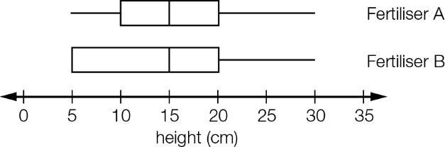

A The median heights are the same.

B The IQR of Fertiliser A is greater than the IQR of Fertiliser B.

C About 50% of the results for Fertiliser B are less than 15 cm.

D The range is the same for both fertilisers.

Question 3 [2.6] [10A]

Using the line of best fit equation w = -2.96t + 14.23, the interpolated value of w where t = 25 is closest to:

A -88.23 B -59.77 C 59.77 D 88.23

Question 4 [3.4]

To sketch the graph of y = -(x − 3)2, the graph of y = x2 will need to be:

A reflected in the y-axis, translated 3 units left

B reflected in the y-axis, translated 3 units right  
C reflected in the x-axis, translated 3 units left

D reflected in the x-axis, translated 3 units right

Question 5 [3.6]

When fully factorised, is:

A  B  C  D 

Question 6 [4.2]

When fully factorised, 3m2 − 12m + 3 is:

**A** 3(m + 2 + )(m + 2 − ) **B** 3(m − 2 + )(m − 2 − )

C 3(m − 2 + )(m − 2 − ) **D** 3(m + 2 + )(m + 2 − )

Question 7 [5.2]

The surface area of the closed cylinder shown is closest to:

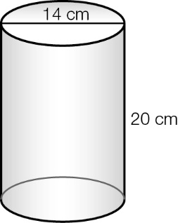

**A**  879.6 cm2 **B** 1187.5 cm2 C 1759.3 cm2 **D**  2990.8 cm2

Question 8 [6.3]

The value of θ in degrees, minutes and seconds in the equation cos(θ) = 0.2917 is:

**A** 16°57'35'' **B** 73°2'24'' C 73°2'25'' **D** 73°4'02''

Question 9 [7.3] [10A]

The solutions to 3 − 4cos(x) = 0 for 0° ≤ x ≤ 360° are closest to:

**A** 41.4°, -41.4° **B** 41.4°, 138.6° C 41.4°, 221.4° **D** 41.4°, 318.6°

Question 10 [9.6] [10A]

The size of α in the diagram below is:

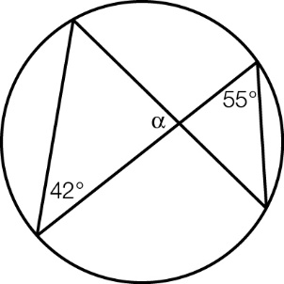

**A** 42° **B** 55° **C** 83° **D** 97°

Question 11 [8.3] [10A]

If P(x) = 2x3 − 3x + 5 and Q(x) = 3x3 − 2x, then P(x)⋅Q(x) is:

A 6x5 − 9x4 + 19x3 − 6x2 − 10x B 6x6 − 13x4 + 15x3 − 6x2 − 10x

C 6x5 + 9x4 + 11x3 + 6x2 − 10x D 6x5 + 9x4 + 19x3 + 6x2 − 10x

Question 12 [10.4]

An eight-sided die, showing the numbers 1−8, is rolled twice. The probability of rolling an even number followed by an odd number is:

**A**  **B**  **C**  **D** 

Question 13 [11.4] [10A]

 is equivalent to:

**A**  **B**  C  **D** 

Question 14 [12.5] [10A]

3x = 6561 in logarithmic form is:

**A** logx(6561) = 3 **B** log3(x) = 6561 C logx(3) = 6561 **D** log3(6561) = x

Question 15 [9.1]

Given ΔABC and ΔDEF are similar, the corresponding side to AB is:

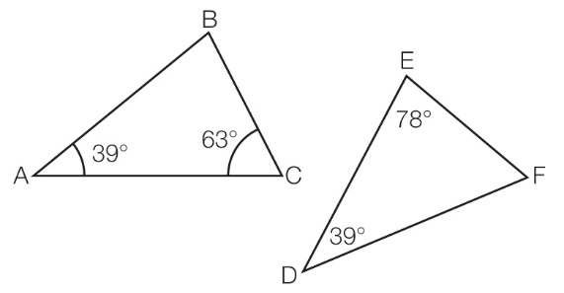

**A** DE **B** EF **C** DF **D** BA

Question 16 [10.1]

A standard six-sided die is rolled and an evenly divided spinner showing 1 to 5 is spun. The sum of the two numbers is added together. The probability that the sum is a multiple of 5 is:

**A**  **B**  **C**  **D** 

Question 17 [13.2]

A loan of $9500 is made at 8.8% p.a., compounded quarterly over a period of   
5 years. The interest accrued would be:

**A** 9500(1 + 0.088)5 − 9500 **B** 9500(1 + 0.022)20 − 9500

C 9500(1 + 0.022)5 − 9500 **D** 9500(1 + 0.088)20 − 9500

Question 18 [13.5]

A desktop computer is purchased for $2500 and will have a resale value of $250 after 5500 hours of use. The unit cost depreciation of the computer is closest to:

**A** $0.41 per hour **B** $0.45 per hour C $0.48 per hour **D** $0.50 per hour

Multiple-choice results: \_\_\_ / 18

Short answer section

Question 19 12 marks [1.3]

Sketch each of the following on separate graphs, showing axes intercepts where they exist, and one other point of your choosing.

**(a)** x − y = 2 **(b)** 5x + 3y = 6 **(c)** y = -3x

**(d)** y = 5 **(e)** x = -2 **(f)** 3x + 2y = -10

Question 20 6 marks [1.6]

(a) A test has 37 questions some of which are worth 3 marks and the remainder worth 2 marks. The test is marked out of 100. How many of each type of question are on the test?

(b) Herbs sell for $4.95 a pot and seedlings are $3.95 a punnet. Rhonda bought 13 items for a total cost of $58.35. How many of each of herbs and seedlings did Rhonda buy?

Question 21 10 marks [3.7]

Simplify the following.

(a)  (b) 

(c)  (d) 

Question 22 6 marks [5.1, 5.7]

(a) Six equally sized circles are punched out of the rectangular piece of metal shown. Find the area not used by the circles, giving your answer correct to 2 decimal places.

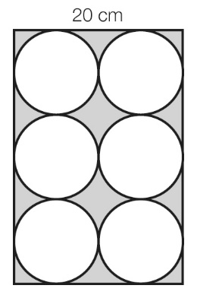

(b) Find the area of the following shape, giving your answer correct to 2 decimal places.

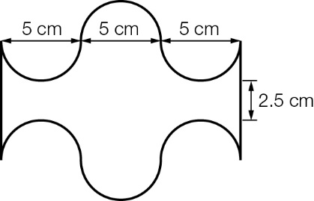

[10A] (c) Find the volume of a 250 g piece of lead with a density of 11.3 g/cm3, to 1 decimal place.

[10A] (d) Find the concentration when 175 mL of cordial concentrate is mixed with 3.5 L of water.

Question 23 2 marks [6.3]

Find the value of θ in each triangle, expressing your answer in degrees, minutes and seconds.

|  |  |
| --- | --- |
| (a)  PM10_PR_E06 | (b)  PM10_PR_E07 |

Question 24 6 marks [6.5]

A scout walks 1.5 km on a bearing 047°T and then walks 2.5 km on a bearing of 085°T.

(a) What distance, correct to 2 decimal places, is the scout from the starting point just prior to returning to the start?

(b) Find the bearing, correct to the nearest degree, the scout should walk on to return directly to the starting point.

Question 25 3 marks [7.5] [10A]

A slide of length 2.96 m makes an angle of 32° with the ground. If the ladder is 2.28 m long what angle, θ, does it make with the ground? Give your answer correct to 2 decimal places as well as correct to the nearest minute.

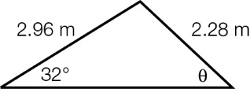

Question 26 7 marks [2.2]

The following data represent the heights, measured in cm, of the players in a netball club.

149 158 172 164 160 172 180 175 160 159 161 173 170

181 179 168 155 149 150 160 172 161 178 159 162 165

167 168 172 173 175 170 172 180 166 159 158 173 170

**(a)** Find the five-figure summary for the data set.

**(b)** Draw a box plot of the data.

**(c)** What are the cut-off values for outliers? Are there any outliers in the data set?

Question 27 6 marks [2.3]

Three classes sat the same mathematics test, marked out of 100. The results for the three classes are summarised in the following table.

|  |  |  |  |  |
| --- | --- | --- | --- | --- |
| Class | Mean | Median | Range | IQR |
| A | 71.93 | 74 | 52 | 29.5 |
| B | 72.03 | 71 | 32 | 16 |
| C | 71.57 | 73 | 31 | 30 |

(a) Which class do you think performed best on the test? Give reasons for your answer.

(b) Assuming Class A had 15 students, write a sample set of results that match the statistics.

Question 28 4 marks [9.1]

Use similar triangles to find the value of x in each of the following.

|  |  |
| --- | --- |
| (a)  PM10_PR_E08 | (b)  PM10_PR_E09 |

Question 29 5 marks [9.5]

(a) (i) Write the properties of the shape shown.

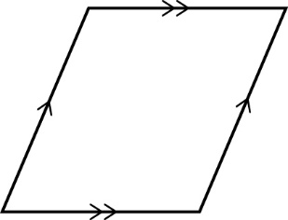

(ii) Use the definitions for quadrilaterals to determine the type of shape.

(b) (i) Write the properties of the shape shown.

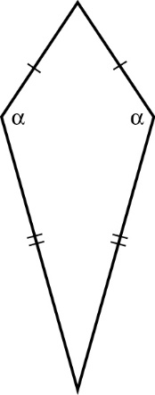

(ii) Use the definitions for quadrilaterals to determine the type of shape.

Question 30 3 marks [9.7] [10A]

|  |  |
| --- | --- |
| Given: ABC and FED are straight lines  G and H are the centres of the circles  JG = MG  AC = FD  Prove: KH = LH | PM10_PR_EA06 |

Question 31 6 marks [4.1]

Solve the following quadratics for x.

(a) 3x2 − 30x + 75 = 0 (b) x2 + 5x − 14 = 0 (c) x2 + 12 = 7x

Question 32 4 marks [8.5] [10A]

Sketch the graph of each polynomial on separate axes, clearly labelling the x- and y-intercepts.

(a) P(x) = (x − 3)(x − 2)(x + 1) (b) P(x) = (x − 1)2(x + 2)2

Question 33 5 marks [10.5]

A class of 25 students in Brisbane is surveyed regarding their support of the AFL team Brisbane Lions and the soccer team Brisbane Roar. Six students support only the Lions, four support only the Roar, while eight support neither. The rest of the students support both teams.

(a) Draw a Venn diagram to represent the situation.

(b) How many students support both teams?

(c) Find the probability that a randomly selected student supports:

(i) neither team

(ii) Roar

(iii) Roar, if you know that they support the Lions.

Question 34 5 marks [11.3] [10A]

Simplify the following.

(a)  (b) 

(c)  (d) 

Question 35 8 marks [12.3]

Simplify the following, expressing your answers with positive indices.

(a)  (b) 

(c)  (d) 

Question 36 4 marks [13.3]

$10 000 is invested for four years with interest compounded quarterly. For the first 2 years the interest rate is 4.25% p.a. and for the last 2 years the interest rate is 4.75% p.a.

(a) How much will the investment be worth at the end of the 4 years?

(b) What single interest rate, applied for the whole 4-year period, would have resulted in the same growth in investment? Give your answer as a percentage, correct to 2 decimal places.

Short answer results: \_\_\_ / 102

Extended answer section

Question 37 12 marks [2.2, 10.1, 10.5]

The gumboot toss is a novelty event in school sports. The distances, in metres, that the students threw the gumboot were:

15.6 41.8 42.3 39.7 42.0 51.6 42.8 19.9 29.6 41.7 51.0 46.3 52.3

47.8 42.9 53.5 49.9 48.8 47.7 39.6 38.7 41.1 43.5 51.8 13.3 44.4

**(a)** Find the mean of the data.

**(b)** Find the five-figure summary for the data.

**(c)** Should any of the distances be regarded as outliers? If so, which values and why?

**(d)** Draw a box plot of the data, correctly identifying any outliers that may be present.

(e) If a student was selected at random from those participating in the gumboot toss, what is the probability they tossed the gumboot further than 50 m?

(f) If a student was selected at random from those participating in the gum boot toss, what is the probability they tossed the gum boot further than 50 m, given it was greater than 45 m?

Question 38 6 marks [9.3]

Complete the following proofs.

(a)

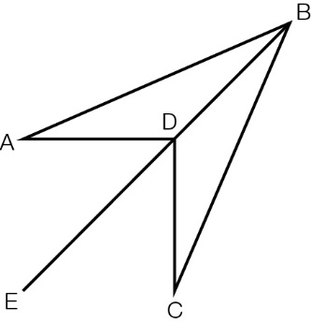

Given: ∠ADE = ∠CDE, AD = DC

Prove: EB bisects ∠ABC

(b)

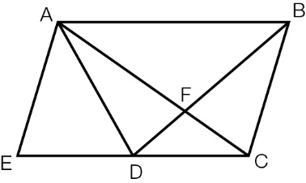

Given: AE = AD, ∠EAD = ∠FAB,

∠AED = ∠ADF

Prove: ΔEAC ≡ ΔDAB

Question 39 12 marks [4.4]

A farmer has 240 m of fencing to make a rectangular paddock.

(a) Complete the table.

|  |  |  |  |  |  |  |
| --- | --- | --- | --- | --- | --- | --- |
| Width (w) | 20 | 40 | 60 | 80 | 100 | 120 |
| Length (l) |  |  |  |  |  |  |
| Area (A) |  |  |  |  |  |  |

(b) Find the formula for the area of the paddock, using only A for the area and w for the width.

(c) Sketch the graph of the function for values of w up to and including 120 m.

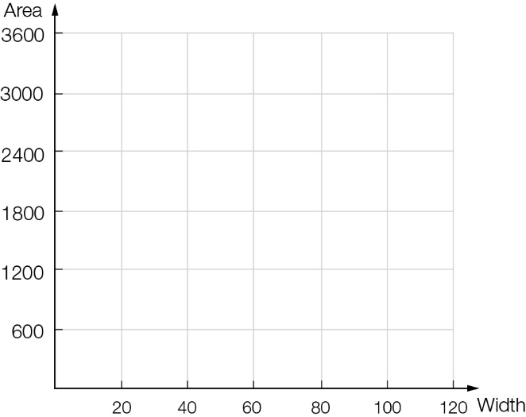

(d) What length and width give the largest area?

(e) Repeat parts **(a)**–**(d)** for a farmer who has 400 m of fencing available.

|  |  |  |  |  |  |  |  |  |  |  |
| --- | --- | --- | --- | --- | --- | --- | --- | --- | --- | --- |
| Width (w) | 20 | 40 | 60 | 80 | 100 | 120 | 140 | 160 | 180 | 200 |
| Length (l) |  |  |  |  |  |  |  |  |  |  |
| Area (A) |  |  |  |  |  |  |  |  |  |  |

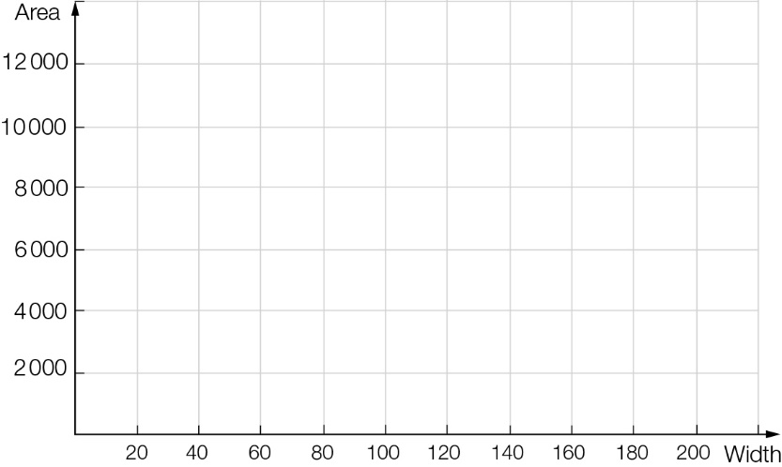

(f) What general conclusion might you reach from these two examples?

Extended answer results: \_\_\_ / 30

TOTAL test results: \_\_\_ / 150